**Laboratory Session 3**

**Conditional Execution**

a/

If(s3 != s4)

S0 -= s3

Else s0 = s1 + s2

S0 -= s4

b/

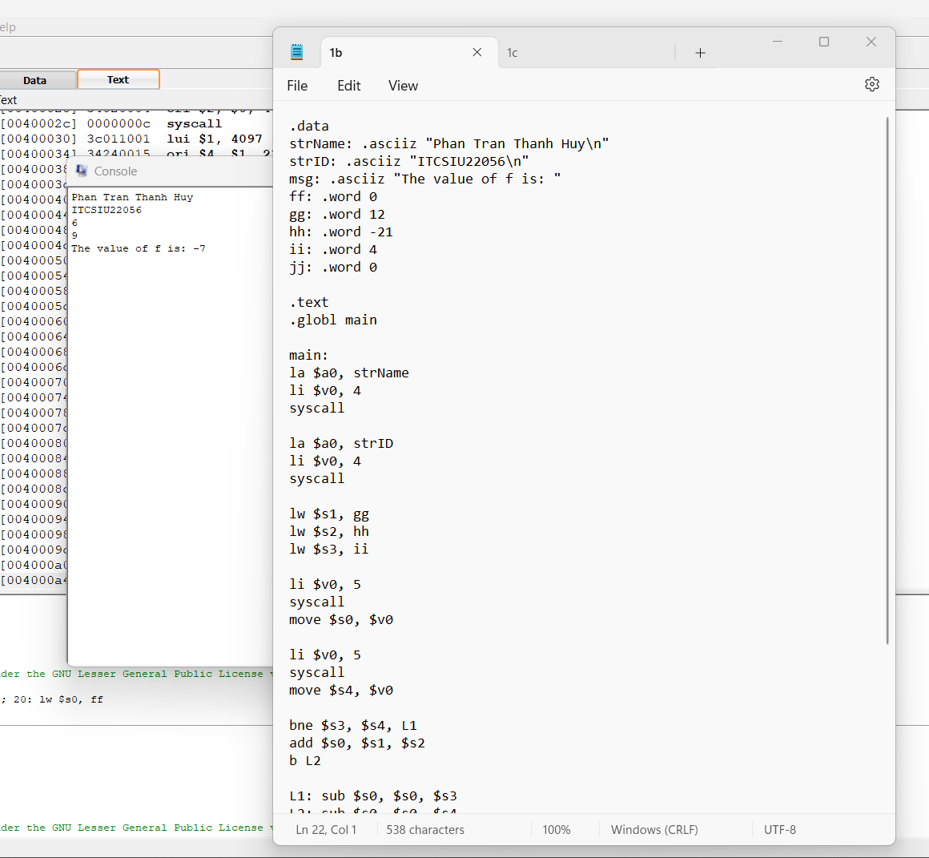

c/

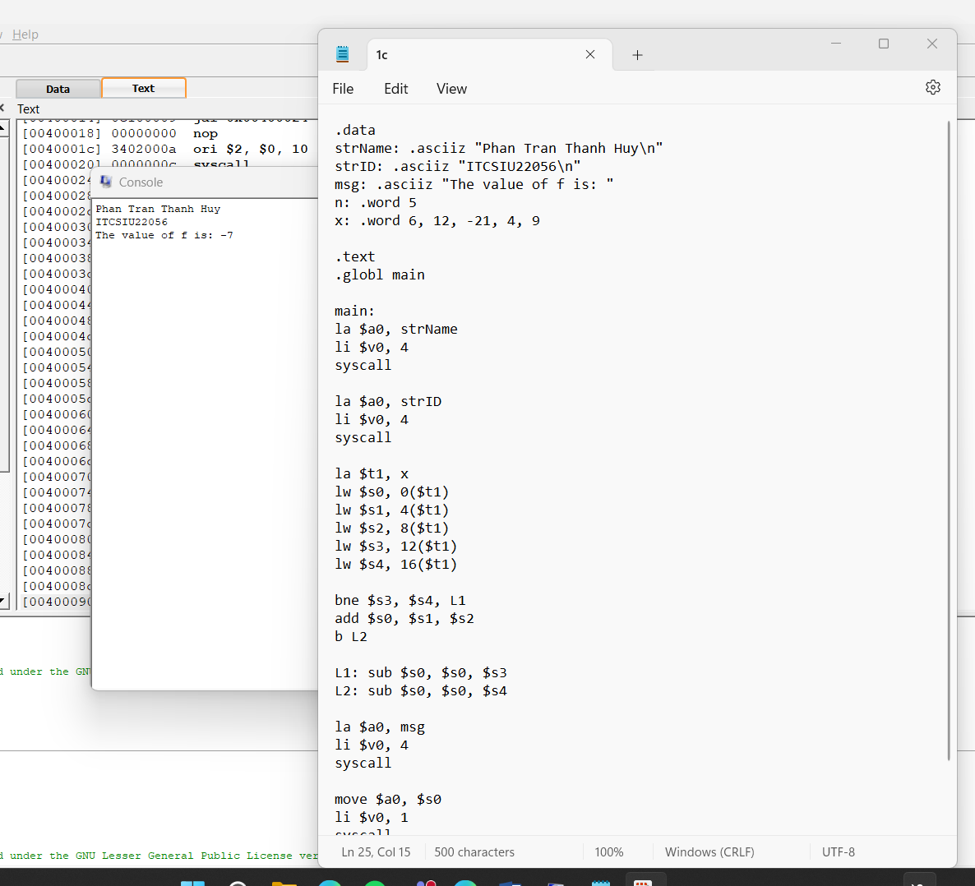

1. **Sum function**

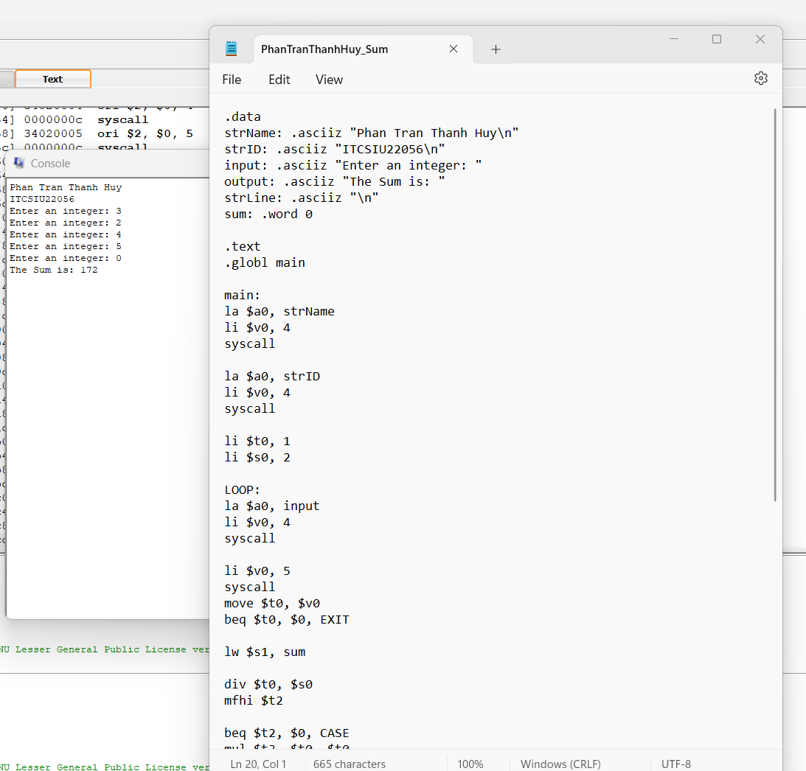

1. **Multiplication Function**

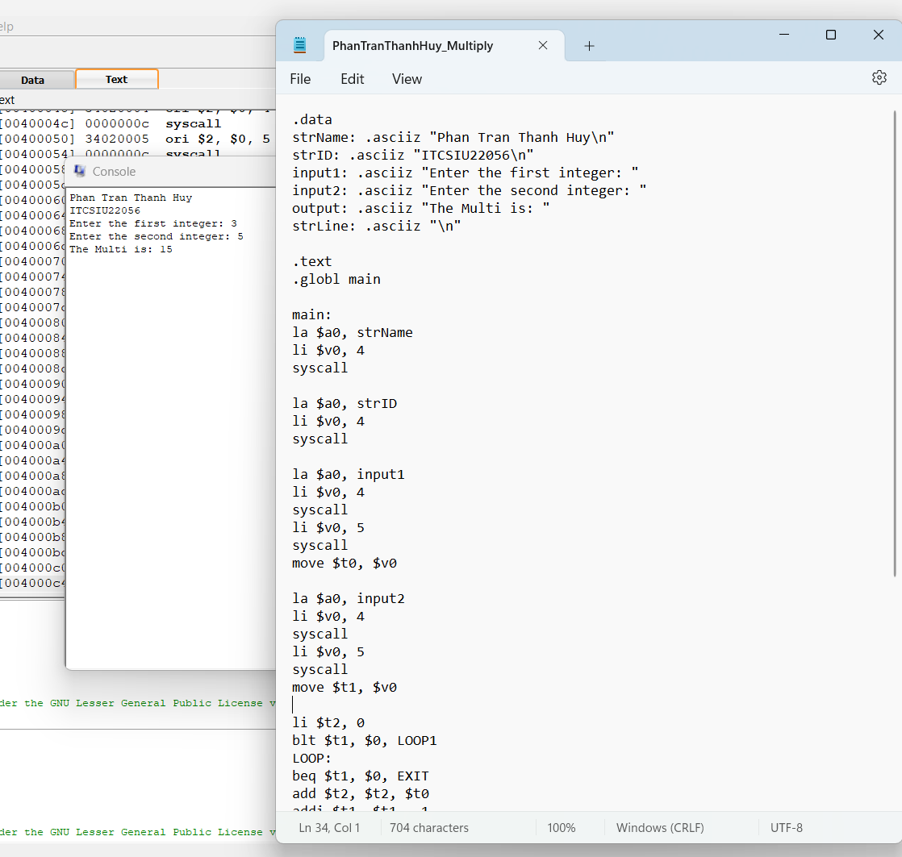

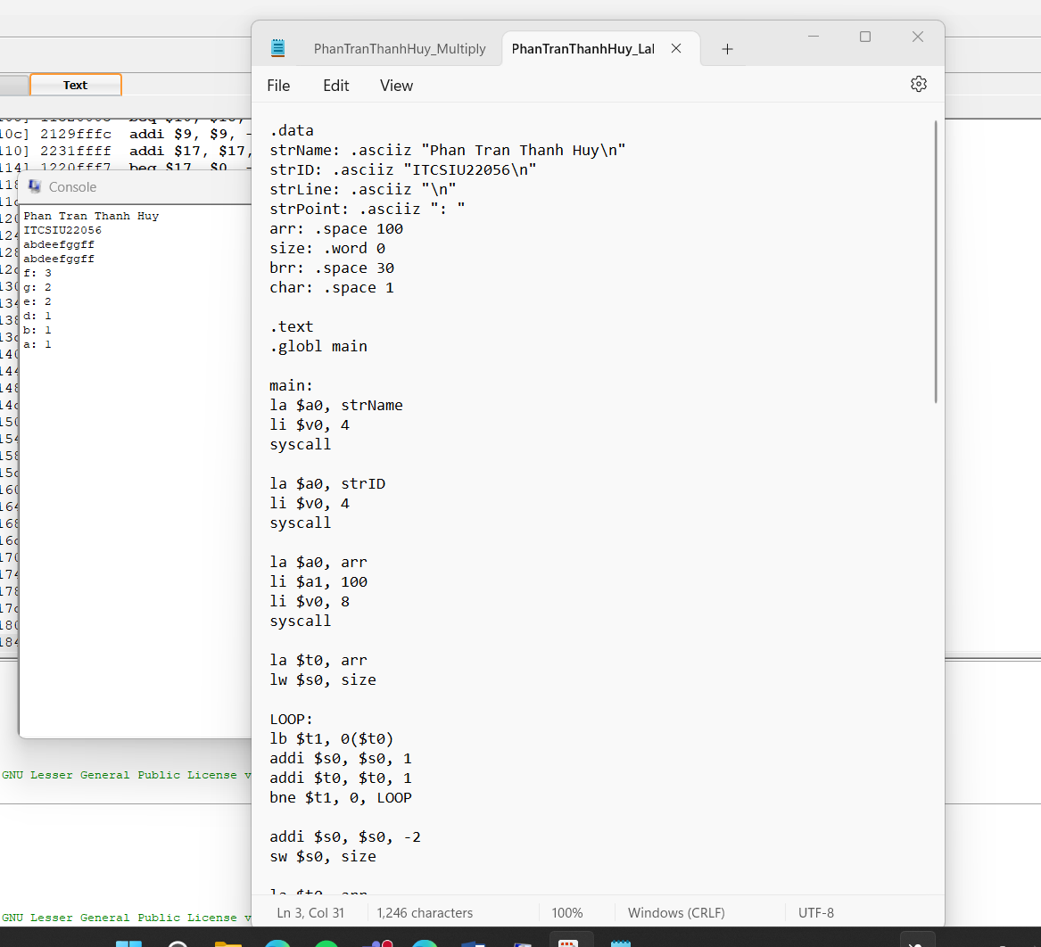

1. **While conditional statement**

